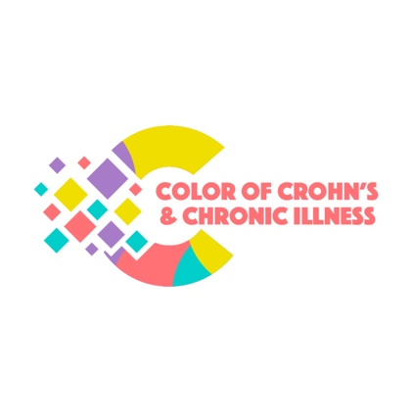

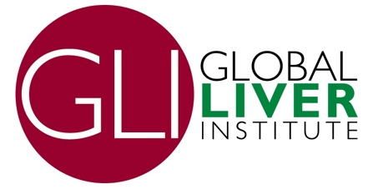

July 31, 2023

Dr. Griffin P. Rodgers, M.D.
Chairperson, National Diabetes and Digestive and Kidney Diseases Advisory Council
Director, National Institute of Diabetes and Digestive and Kidney Diseases
9000 Rockville Pike
Bethesda, MD 20892
Dear Dr. Rodgers:
We are writing to nominate Julius M. Wilder MD, PhD to be a member of the National Diabetes and Digestive and Kidney Diseases Advisory Council (NDDKAC). Not only is Dr. Wilder an accomplished gastroenterologist, transplant hepatologist, and medical sociologist with a national reputation in health equity, he would bring much-needed diversity to its work.
We have attached the letter of interest provided by Dr. Wilder for your consideration. We would highlight his early experience in an HCBU and his service as the inaugural Chair for Duke’s Department of Medicine (DOM) Diversity, Equity, Inclusion, and Anti-Racism committee (DEIAR). He has experience working toward the career advancement of researchers that represent the diversity of gastrointestinal patients and the robust community-engaged research that will serve to improve health and health equity. He is committed to serving in this role and dedicating the time that is required to make a difference.
Our organizations share a strong interest in NIDDK advancing a focus on the gastrointestinal health of Black and Hispanic Americans by ensuring its health disparities and health equity research appropriately explores prevention, diagnosis, and treatment of gastrointestinal diseases, including liver disease. Doing so will require an appropriate level of funding dedicated to gastrointestinal diseases allowing NIDDK to address these diseases from an equity perspective. We believe Dr. Wilder is the right candidate for the NDDKAC to bring a unique and impactful perspective to your work on health equity.
In closing, we strongly support Dr. Wilder’s appointment to the NDDKAC. We understand there are several upcoming expiring terms for which he would be an ideal candidate. Thank you for your consideration and we look forward to hearing from you about his nomination. Please reach out to Donna R. Cryer, JD at dcryer@globalliver.org for additional information.

Sincerely,

Color of Crohns & Chronic Illness (COCCI)
Digestive Disease National Coalition (DDNC)
Global Liver Institute (GLI)
The Association of Black Gastroenterologists and Hepatologists (ABGH)

cc: Dr. Stephen James, Director, Division of Digestive Diseases and Nutrition

